SINGARENI COLLIEIES WOMEN’S DEGREE & PG COLLEGE KOTHAGUDEM
Report on National Service Scheme(NSS) Activities

Aims and Objectives

As the third component of education, the NSS is a part of our academic, social, and personal lives. It enables students to actively offer their time and talents to the betterment of their society and country, thereby assisting in the development of their personalities. As a result, the NSS provides the ideal venue for students and youth across the country to become involved in real-life social activities and, as a result, become responsible citizens of India.

Motto of NSS
“NOT ME BUT YOU”

The Motto This embodies the essence of democratic living and emphasizes the importance of unselfish service, respect for the other's point of view, and consideration for fellow humans. It emphasizes that an individual's well-being is ultimately dependent on the well-being of society as a whole. As a result, the NSS should make it a goal to live up to this philosophy in its daily activities. The

NSS Symbol
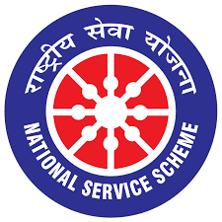
The National Service Scheme's symbol is based on the chariot wheel of Odisha's Konark Sun Temple. The Sun Temple's massive wheels represent the cycle of creation, preservation, and release, as well as the movement of life across time and space. The symbol's design, a simplified version of the sun-chariot wheel, emphasizes movement. The wheel represents life's ever-increasing cycle. It represents both continuity and change, implying the NSS's ongoing commitment to societal development and advancement.
About the NSS
The National Service Scheme (NSS) had its birth on September 24, 1969, during the Gandhi centenary year. The scheme was first launched in 37 universities comprising 40,000 students.

Today the NSS has become the largest Government organization of students in the country comprising members from the +2 level to the college and university levels. The strength of volunteers has now increased to more than 30 lakhs, which makes the NSS one of the largest student forces in the world. The number of students strength increased from 40,000 to over 3.8 million up to the end of March 2018 students in various universities, colleges, and institutions of higher learning have volunteered to take part in various community service programs. The strength of NSS volunteers makes the NSS one of the largest student forces in the world.

Details of NSS Programme Officers
UNIT –I | Smt. G.Sunitha  Lect. in Political Science, SCWDC  NSS Programme Officer. | 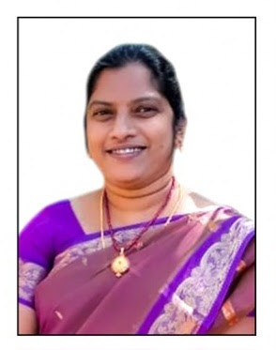
UNIT –II | Smt.K.AshaJyothi  Lect. in English, SCWDC  NSS Programme Officer. | 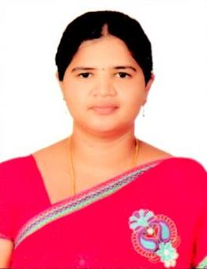
UNIT –III | Smt. R. Krishnaveni  Lect. In Commerce, SCWDC  NSS Programme Officer. | 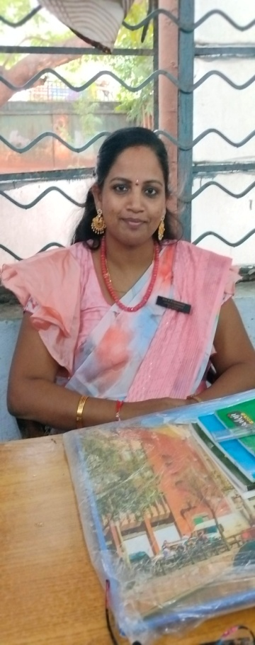

- NSS Formation Day 2023

- In connection with NSS Formation Day 2023 NSS PO’s conducted Essay Writing, Elocution,Singing, Mehendi, Dance, Fancy Dress and Rangoli competitions on 23rd September 2023.
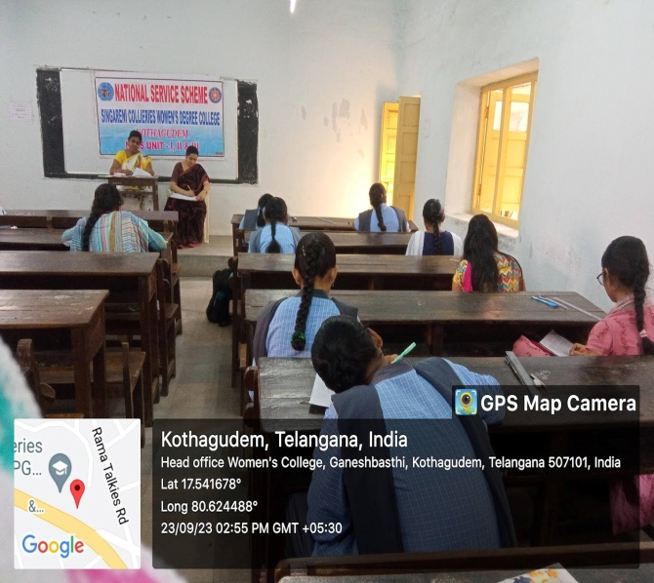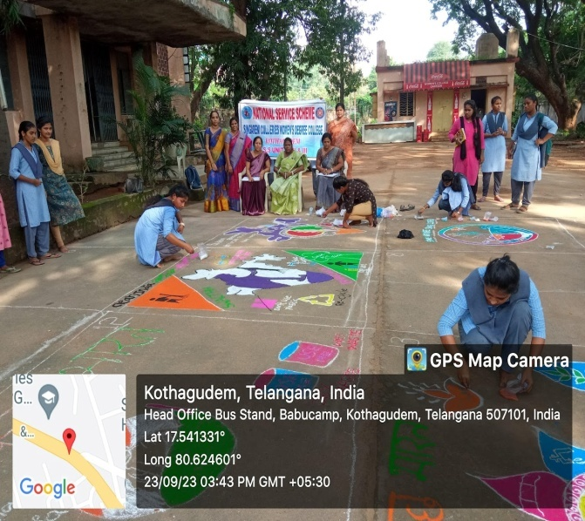

- Celebrated NSS Formation Day on 25th September 2023. Dr.CH.Sarada, Principal, SCWDC is the chief guest of the programme. Distributed Prizes for the winners.
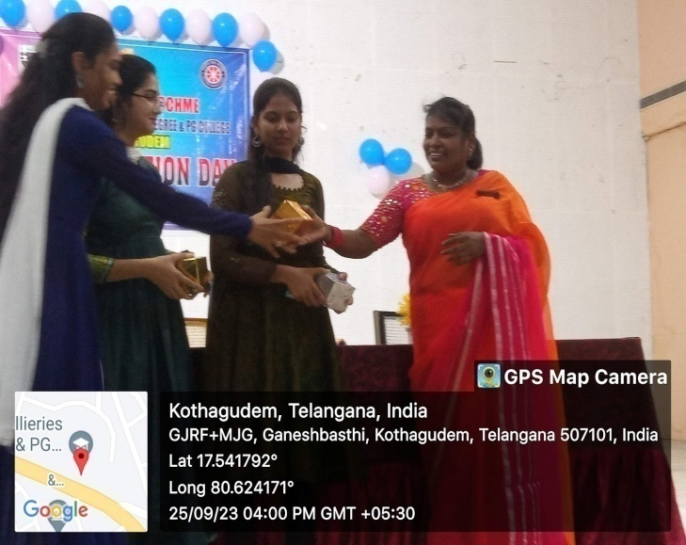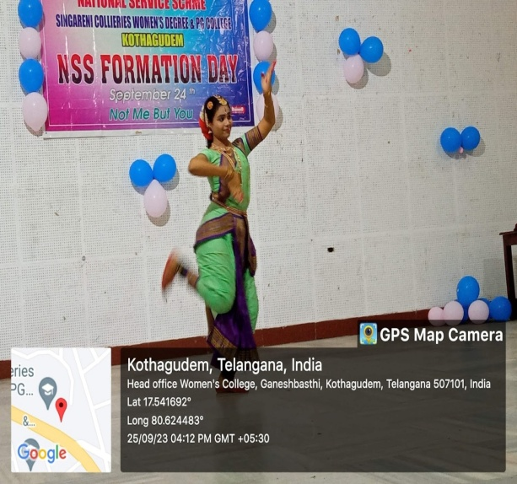

- Gandhi Jayanthi

- In connection with Gandhi Jayanthi NSS PO’s organised Swatch Bharat Programme at our college and took pledge on 1st October 2023.

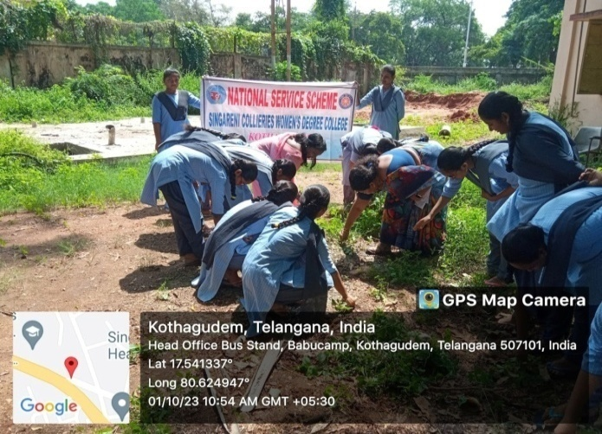

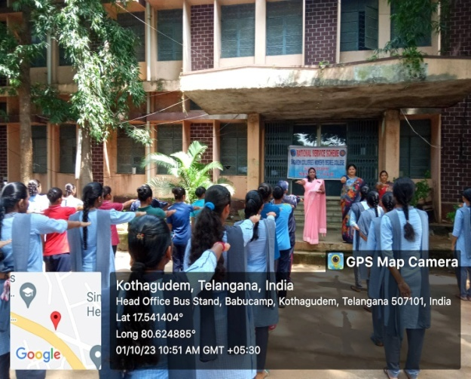

- Pre-RD Selections
In connection with Pre-Republic Day celebrations Kakatiya University conducted Pre-RD selections on 3rd October 2023. Two SCWDC NSS volunteers selected for this camp.
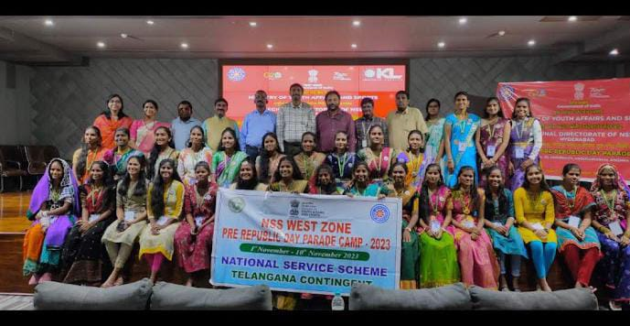
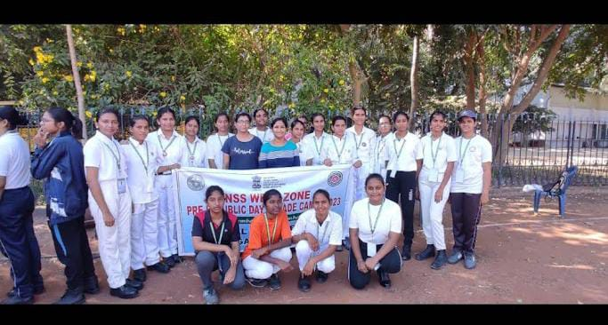

- Medicinal Plant Exhibition

NSS Po’s organised Medicinal Plant Exhibition on 7th October 2023. The Singareni Green Ambassador Mr. Mokkala Venkataiah garu is the chief Guest.
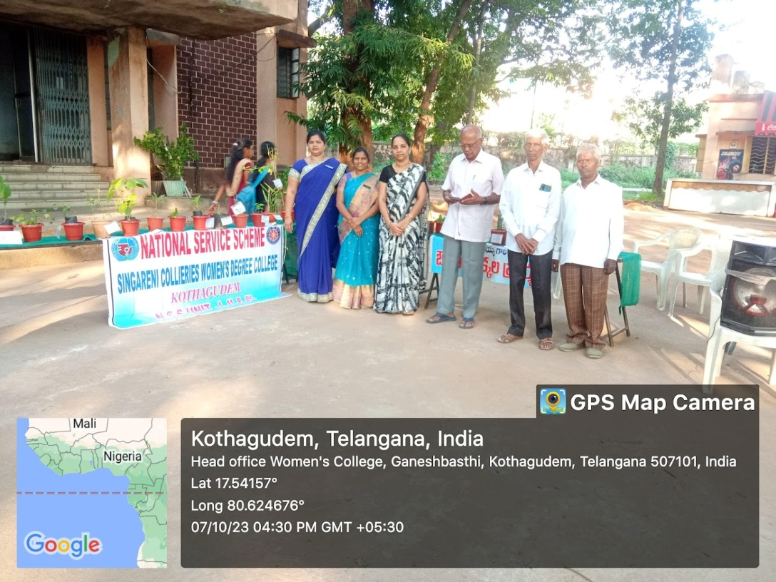
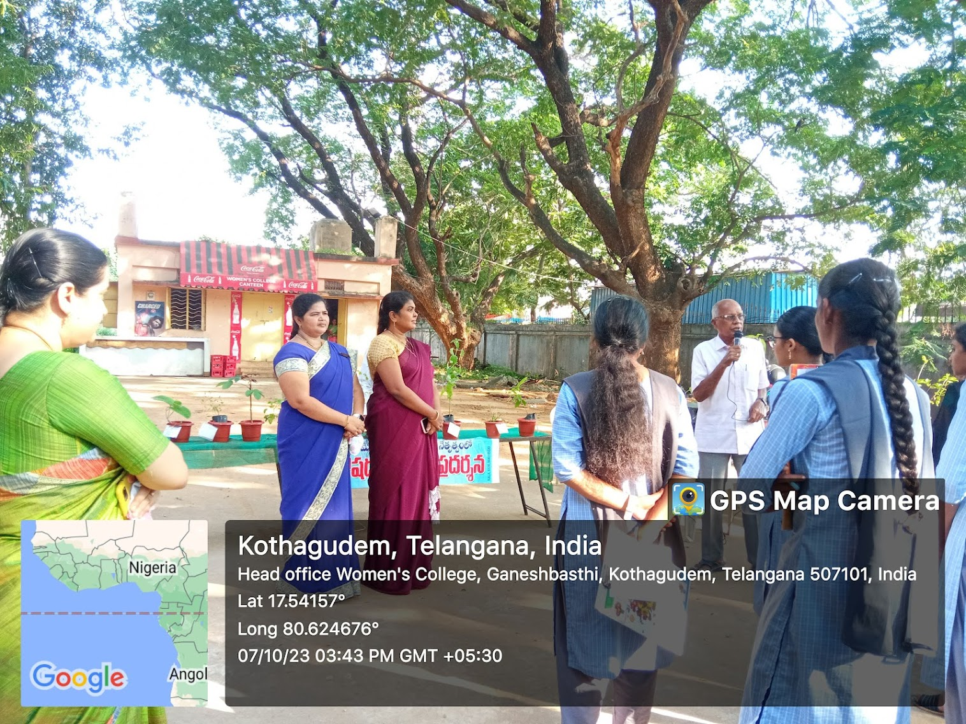
- Amruth Kalash Yatra

- NSS Po’s and Volunteers participated in “Amruth Kalash Yatra” programme on 12th October 2023 organized by Ministry of India. “Meri Maati Meri Desh” campaign comprises collection of mitti and rice grains from over 6lakh villages in rural areas and from wards in urban areas which is sent to block level and then to the state capital.
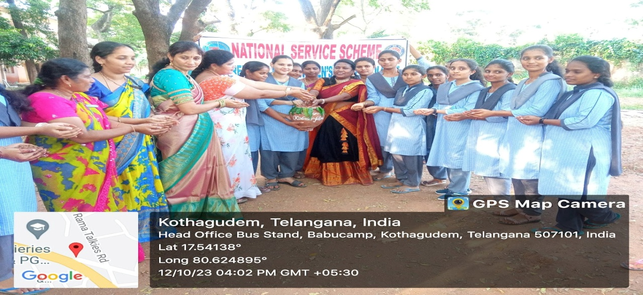

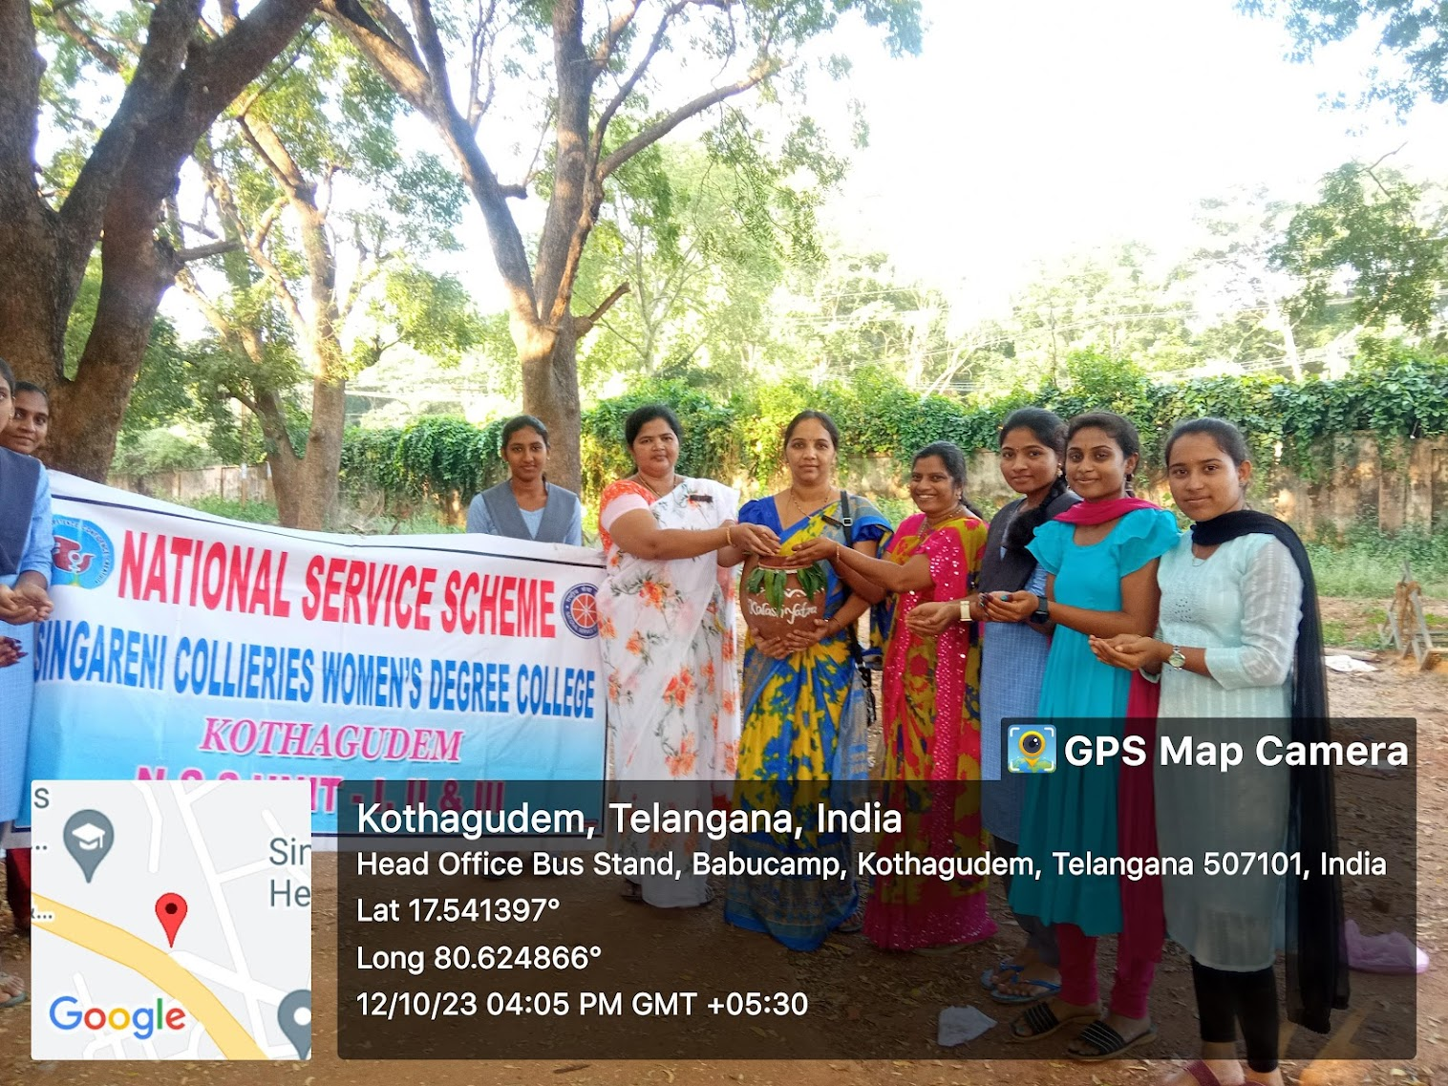

- Republic Day Parade
- NSS Unit-II Volunteers Kum.S.KavyaSri of III MCCS and Kum. K.Indu of II MSCS Participated in Pre Republic Day Parade Camp – 2023 at Vijayawada from 1st to 10th November 2023.
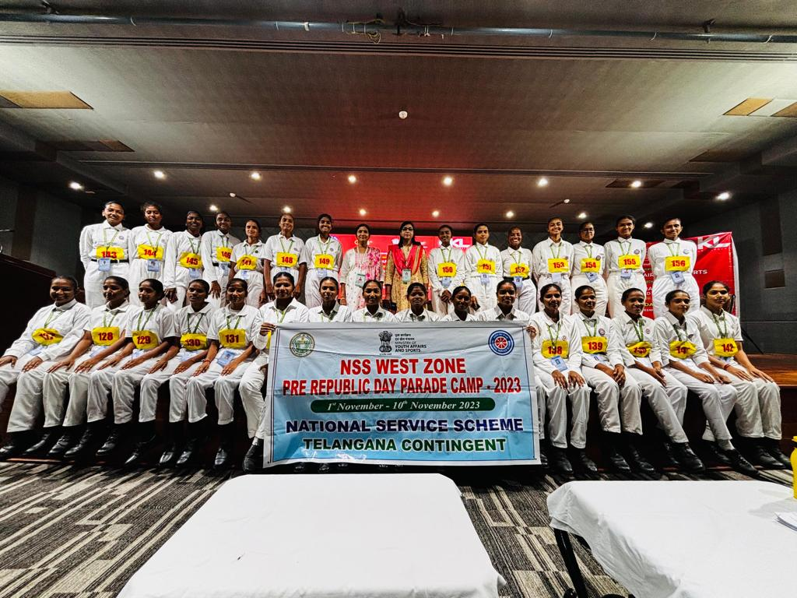

- Communal Harmony Campaign

- In connection with Communal Harmony Campaign Week-2023 NSS PO’s conducted Poster Making competition on 23rd November 2023.

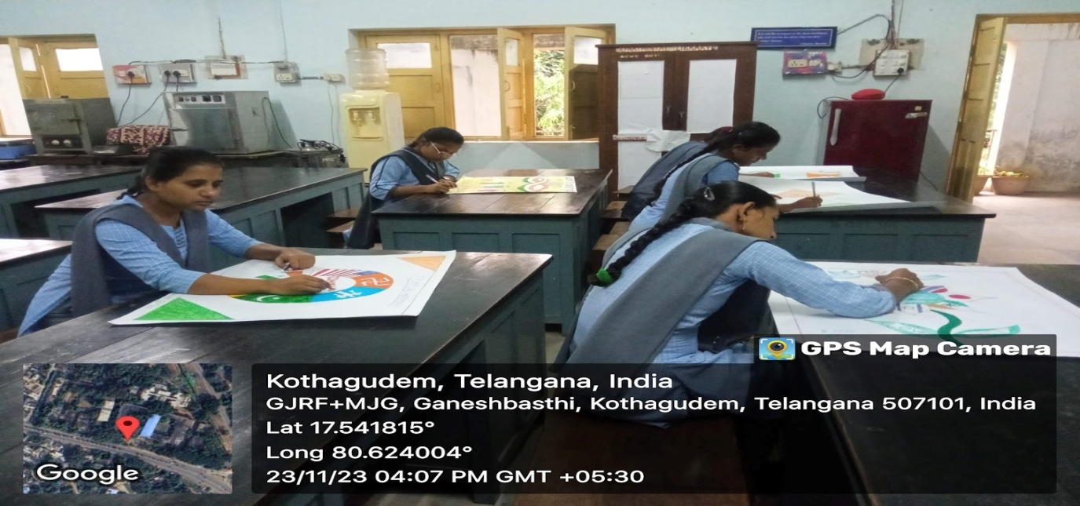

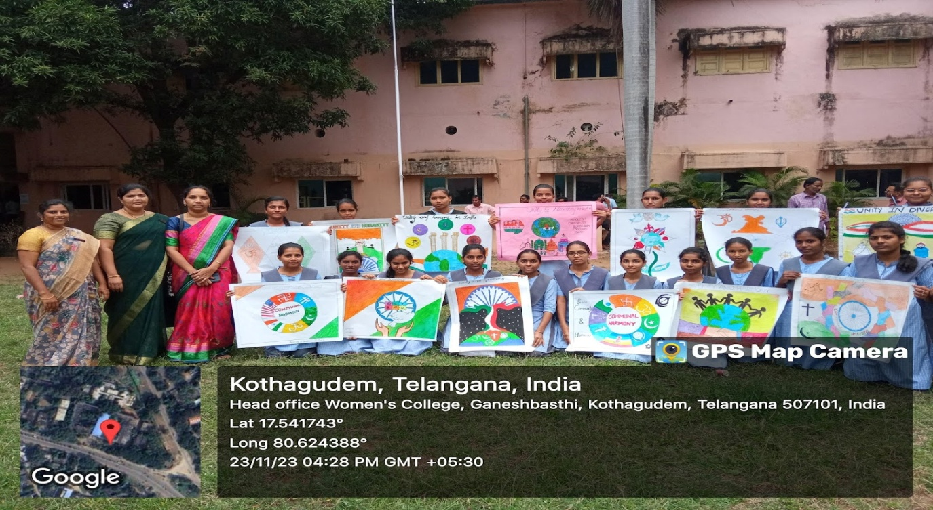

- World Aids Day
- NSS PO’s and Volunteers participated in a Rally and took oath in connection with WORLD AIDS Day on 1st December 2023.

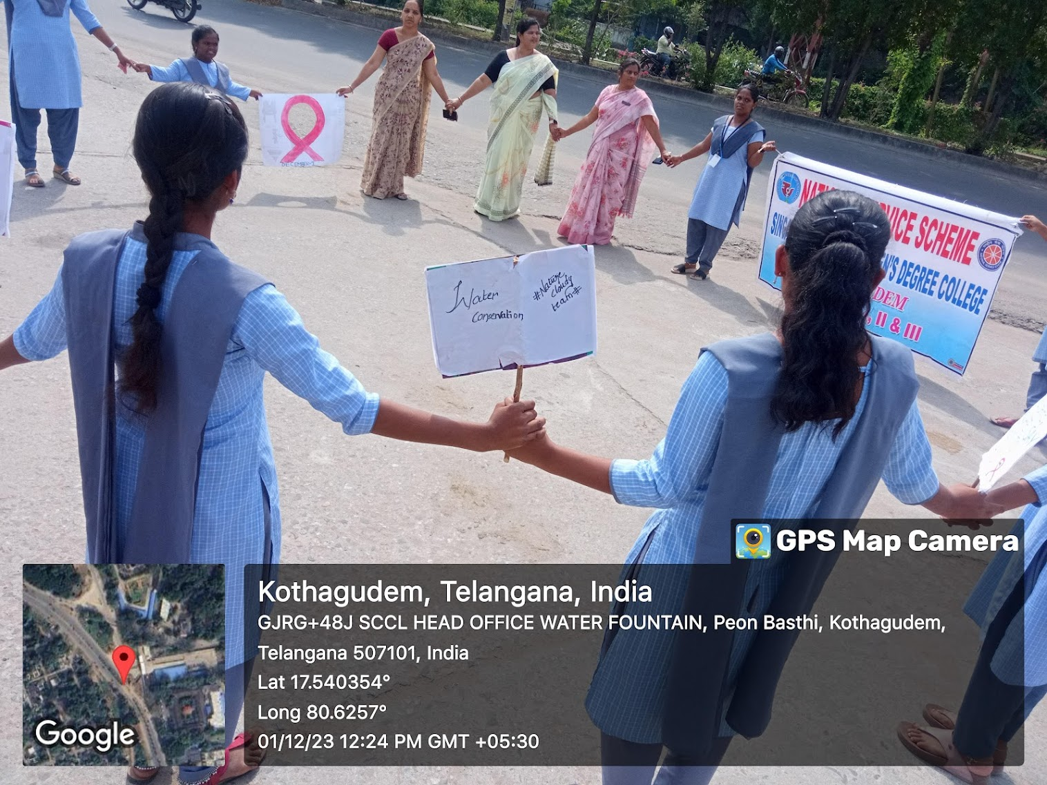

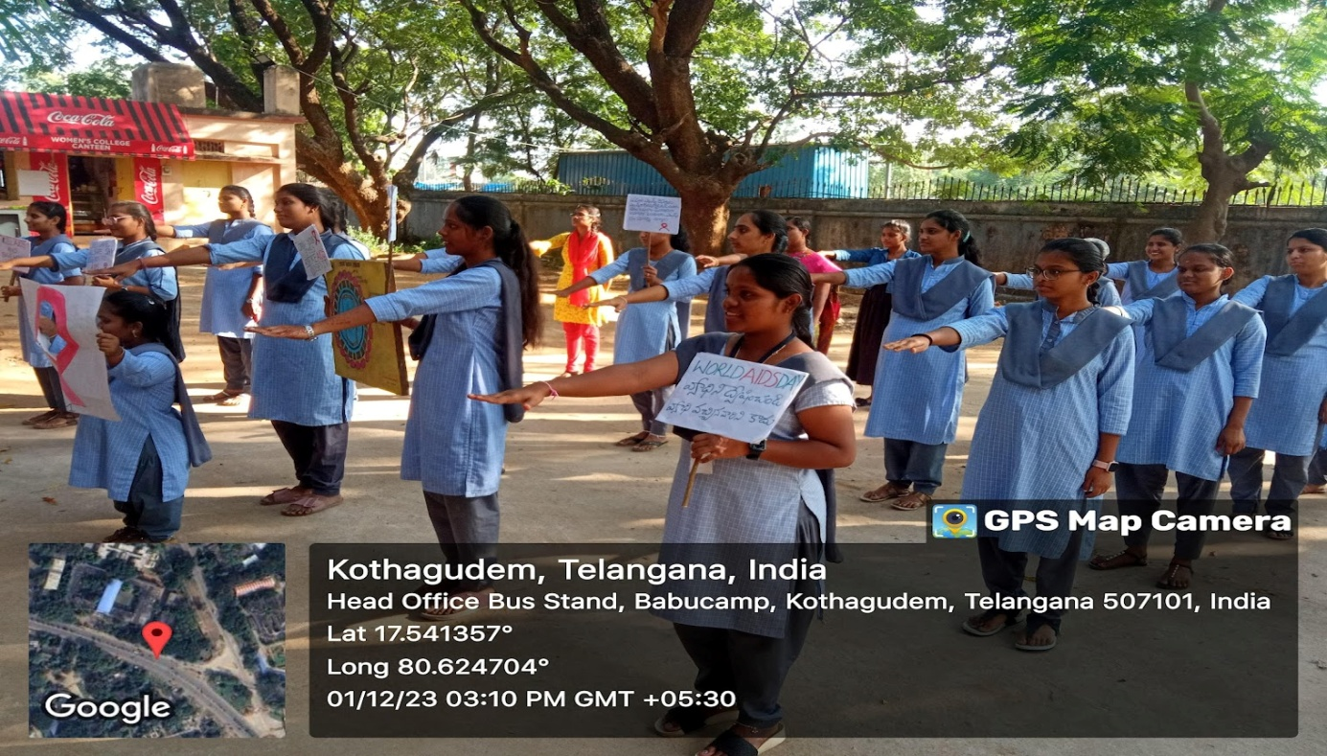

- National Voters Day

- NSS PO’s and Volunteers took oath on 25th January 2023 and participated in 2K Run from Post Office to Laxmidevipally Market Yard in connection with National Voter Awareness Week organized by SWEEP, Govt. of Telangana.

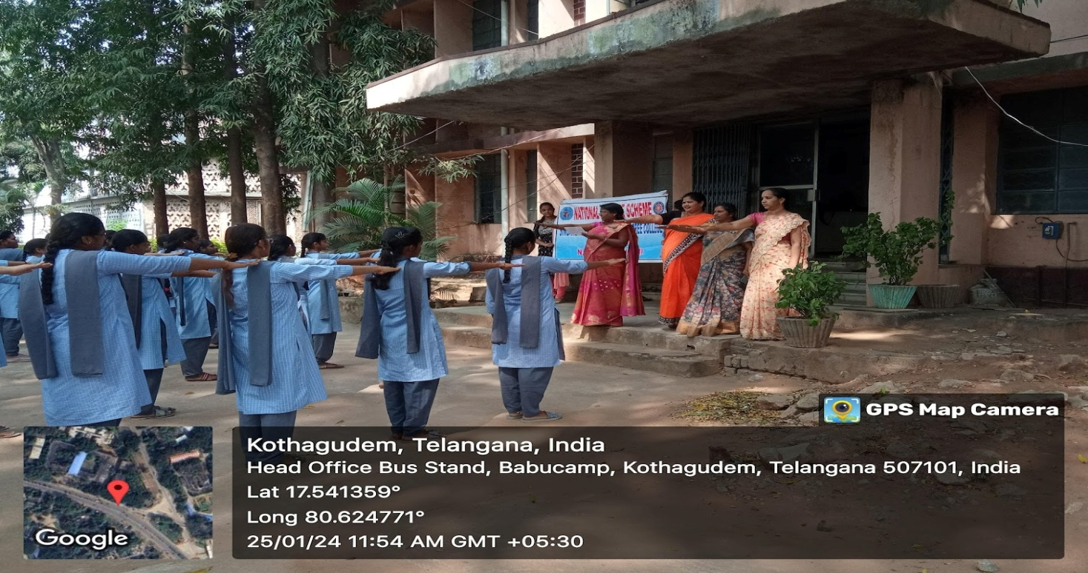

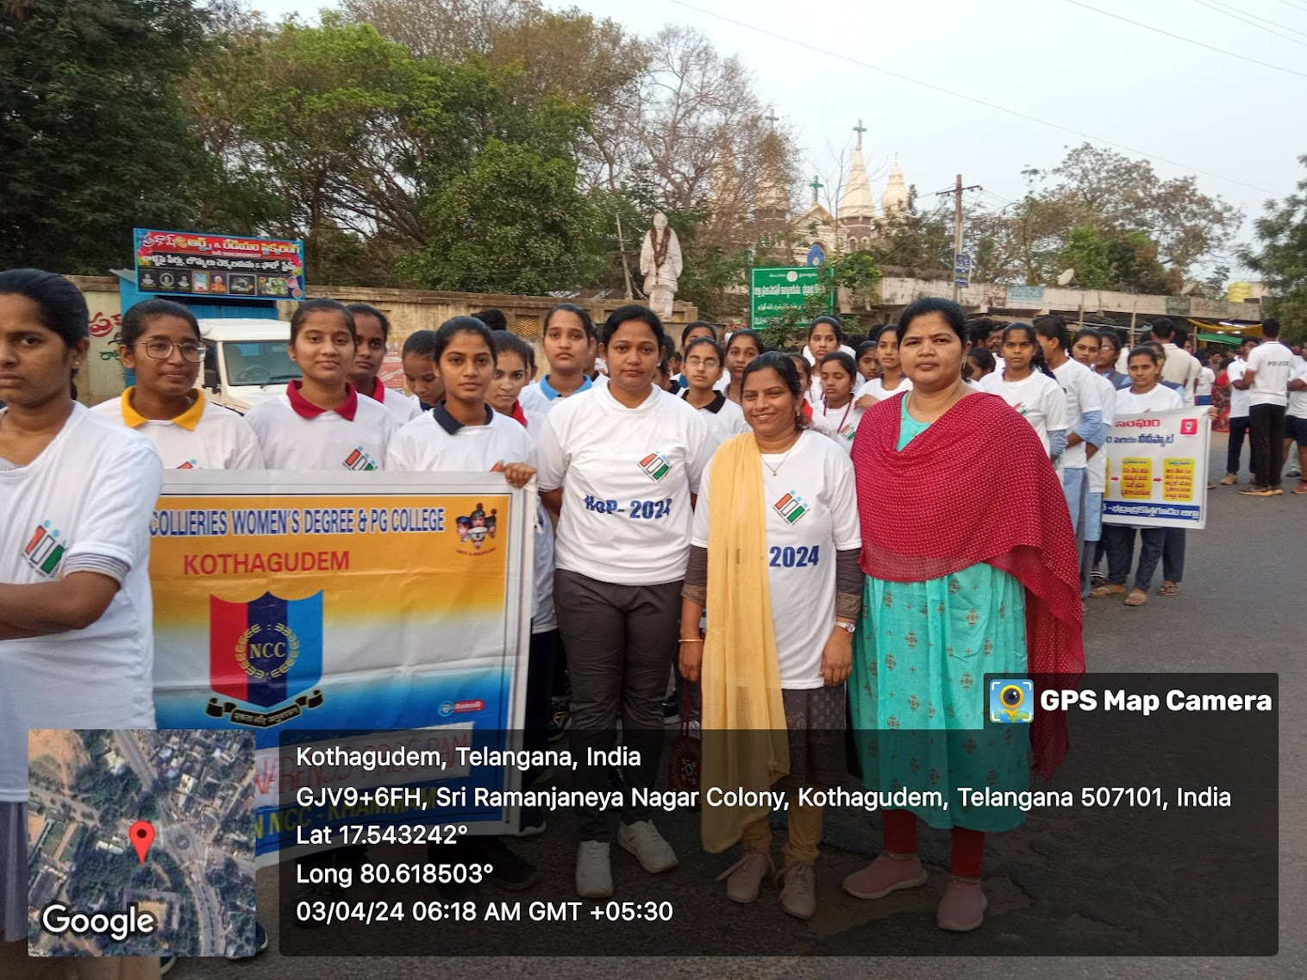

- NSS Programme Officers Meet

- NSS UNIT I, II &III PO’s attended NSS Program Officers Meet at Khammam on 30th January 2024. Dr.Esam Narayana, NSS Coordinator, Kakatiya University is the chief guest of the program.

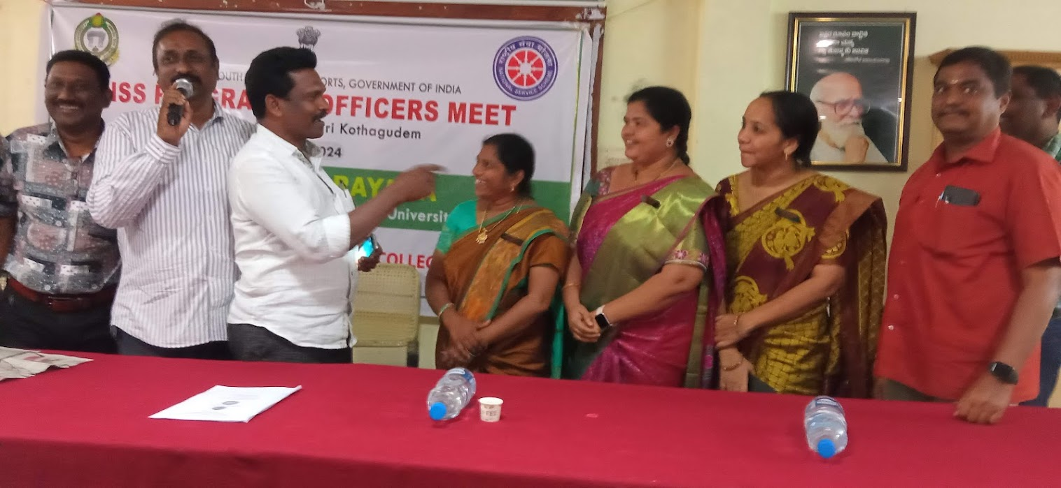

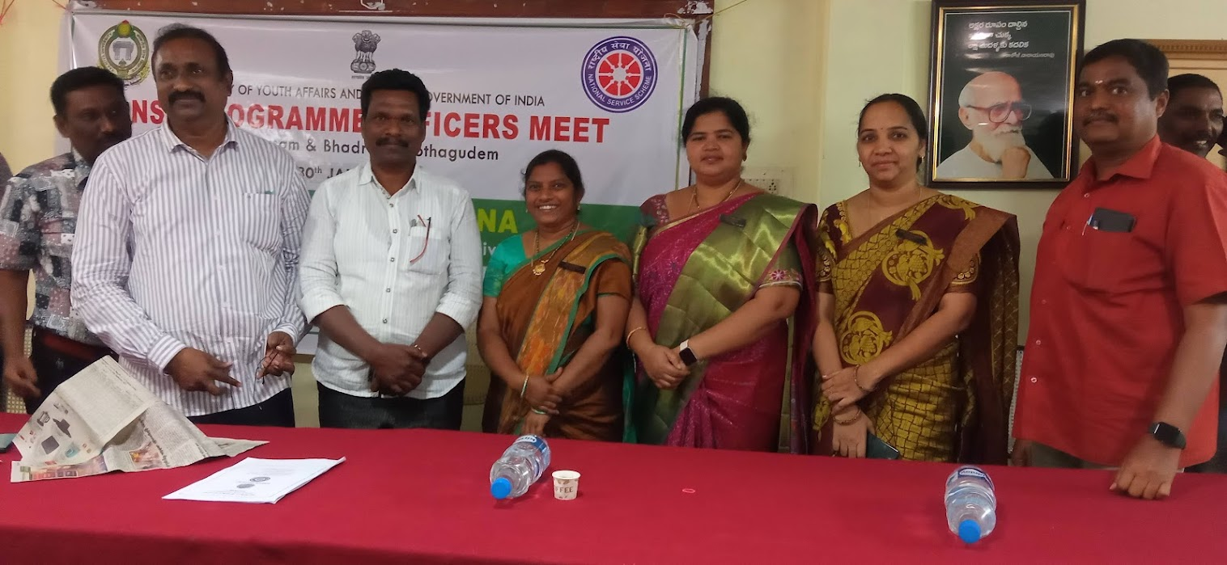

- International Yoga Day – 2024

- In connection with International Yoga Day NSS PO’s and Volunteers participated in Yoga Training Programme on 21st June 2024. Mr. Srinivasa Raju, Audit Officer, SCCL is the chief guest.
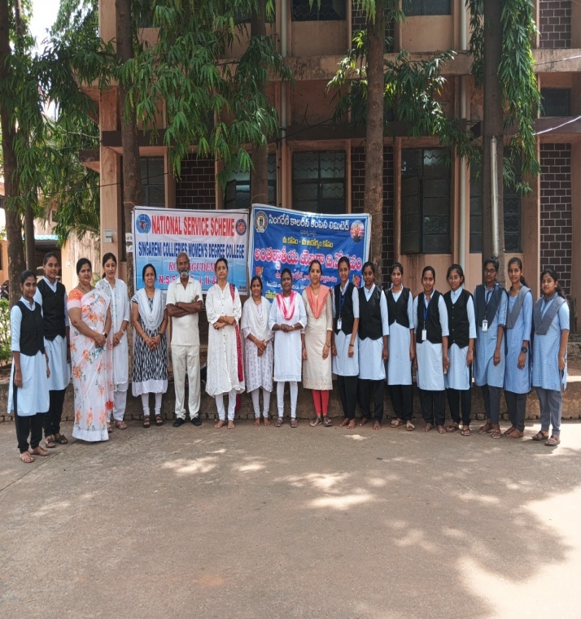

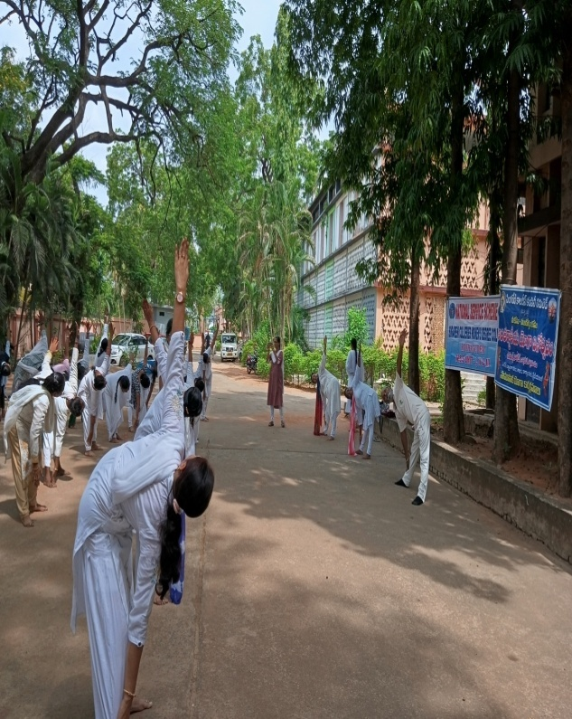

- International Against Drug Abuse and Illicit Trafficking

- On account of International against Drug Abuse and Illicit Trafficking NSS PO’s and Volunteers participated in a rally from Post Office to Railway Station on 26th June 2024. Sri. Jitesh Patel, IAS, Collector and Sri.b.Rohith Raju, IPS are the chief guests of the programme.
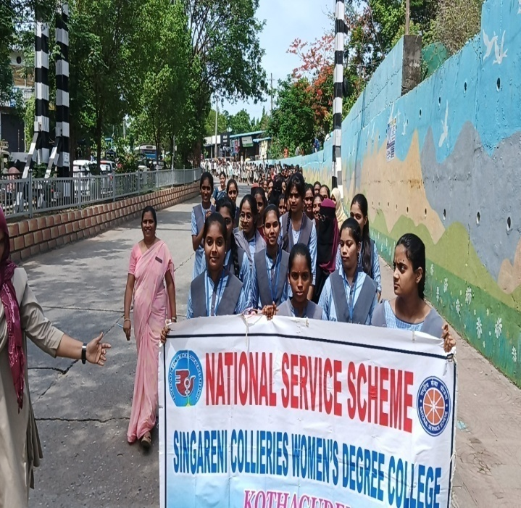
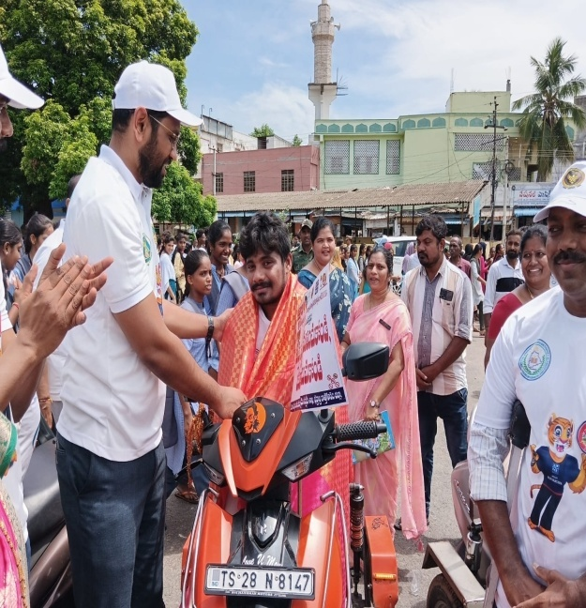

- World Population Day -2024

- In connection with World Population Day NSS Po’s organized an extension lecture on 11th July 2024. Sri.D.Pullaiah, MRO, Kothagudem town is the chief guest of the programme.

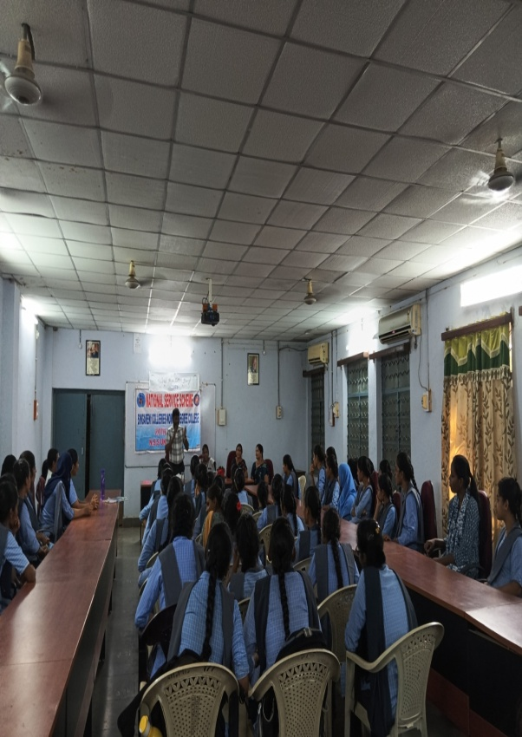

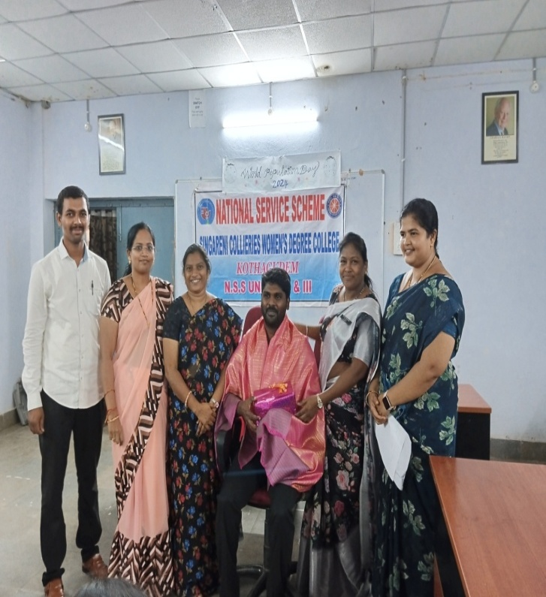

- Har Ghar Tiranga Campaign
- In connection with Har Ghar Tiranga Program NSS PO’s and Volunteers participated in a Rally on 15th August 2024. Participants carry the National Flag, highlighting the spirit of unity and fitness.
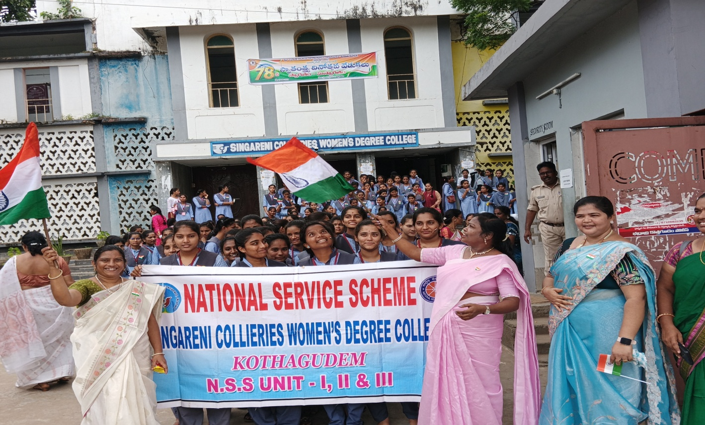

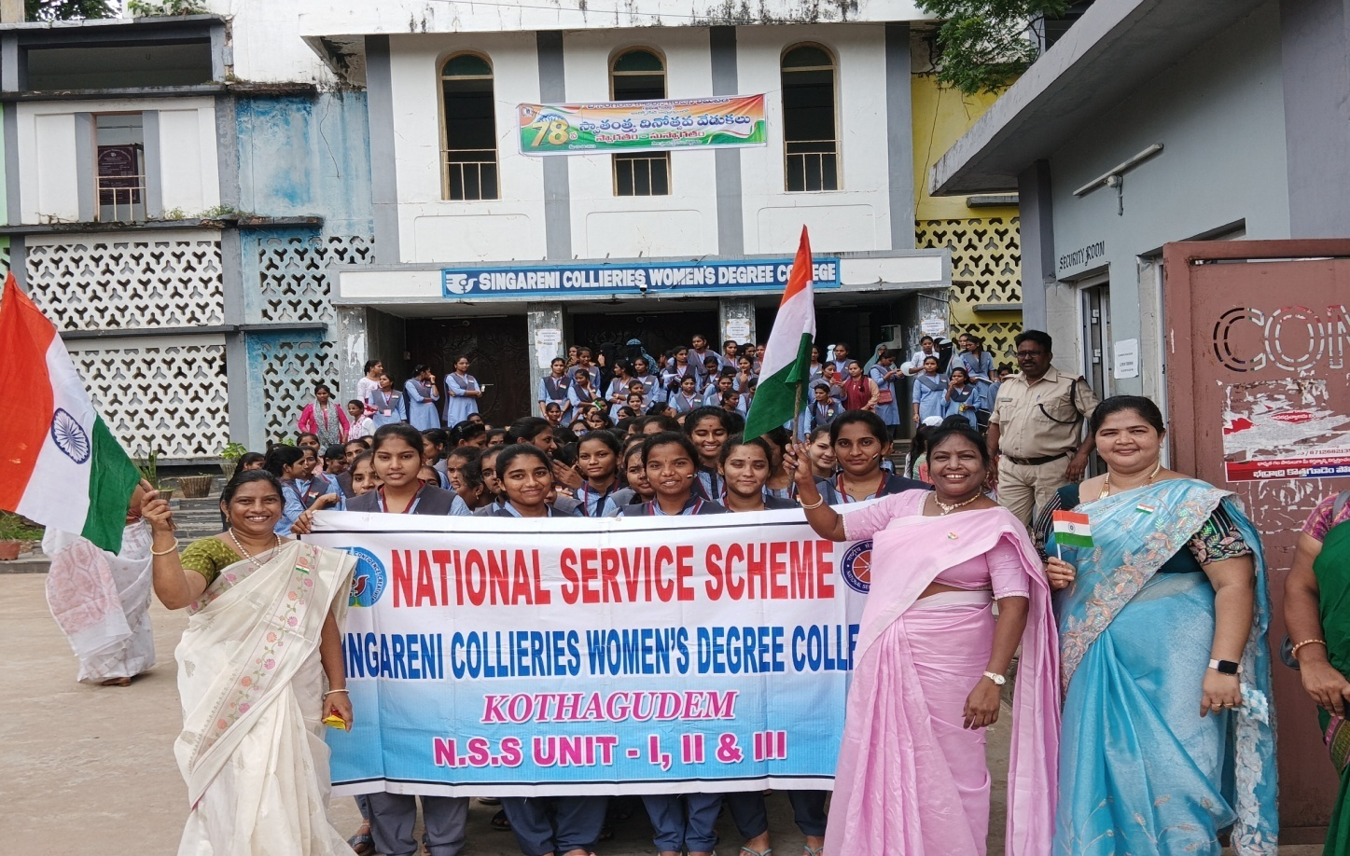

- Plantation Program
- NSS PO’s and Volunteers conducted “Swatchadanam-Pachadanam” Program on 4th September 2024. Planted Fruit and Flower saplings in college premises.
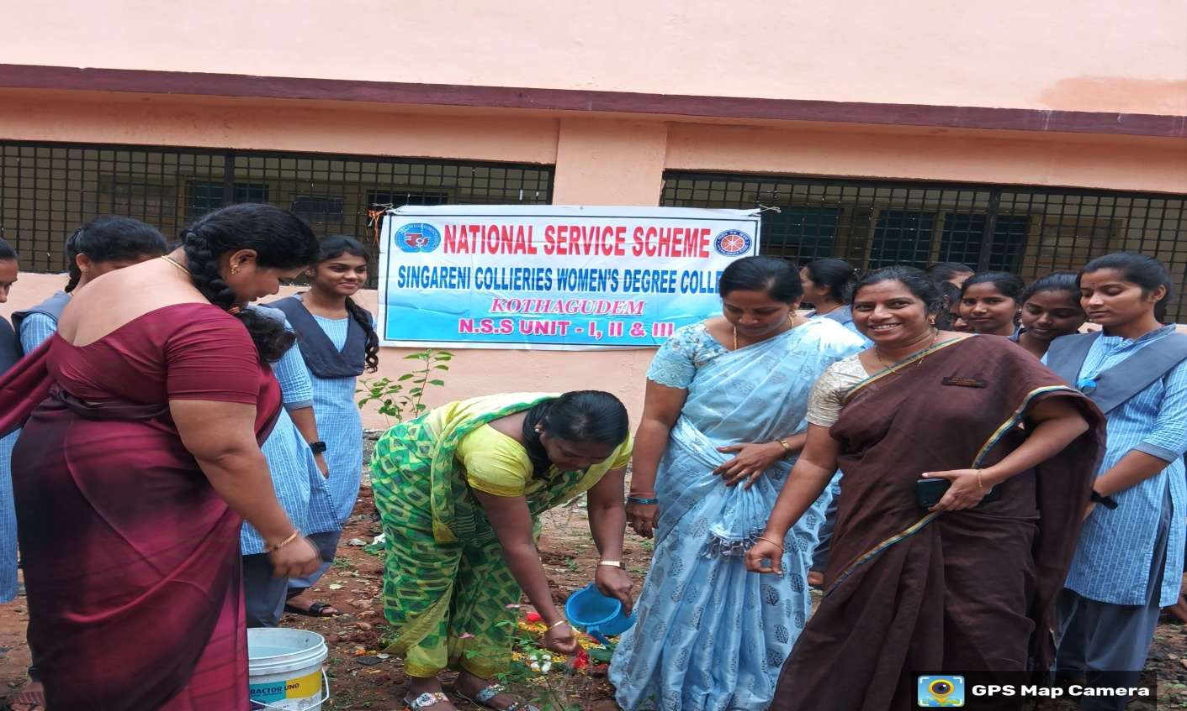

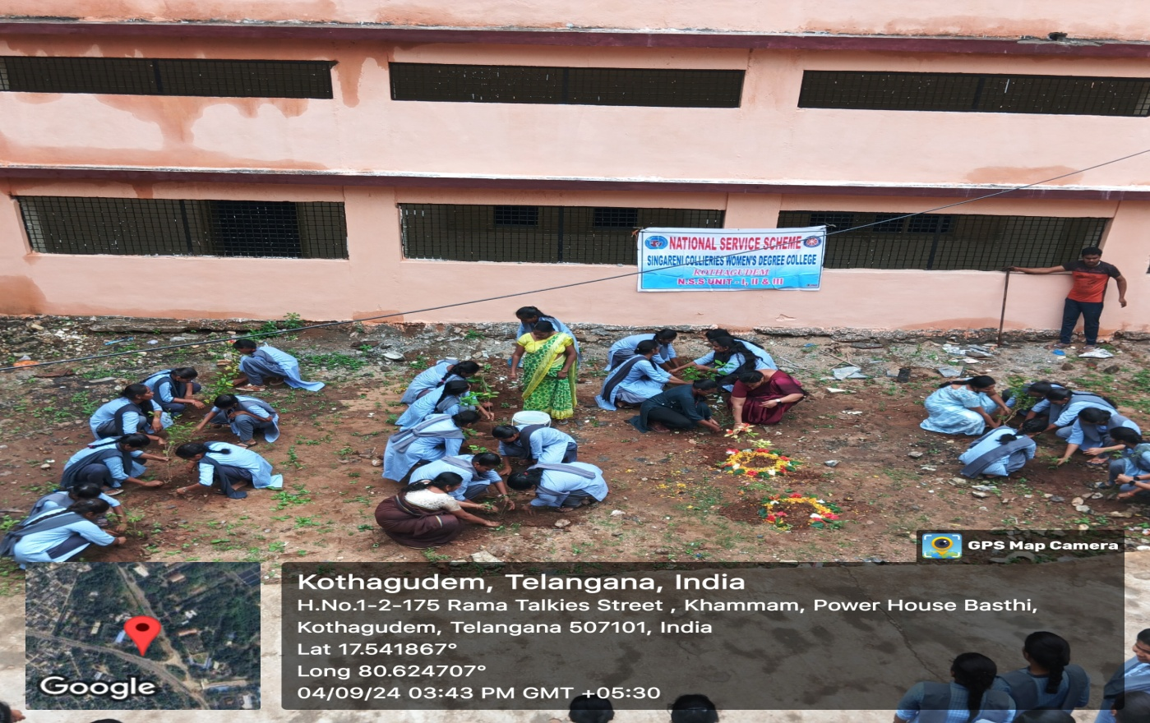

- Cyber Crime Awareness Program

- NSS PO’s organized an Awareness Program on Cyber Crime on 14th September 2024. Miss.K.Ramadevi, SI, She Team District Coordinator is the chief guest of the program.

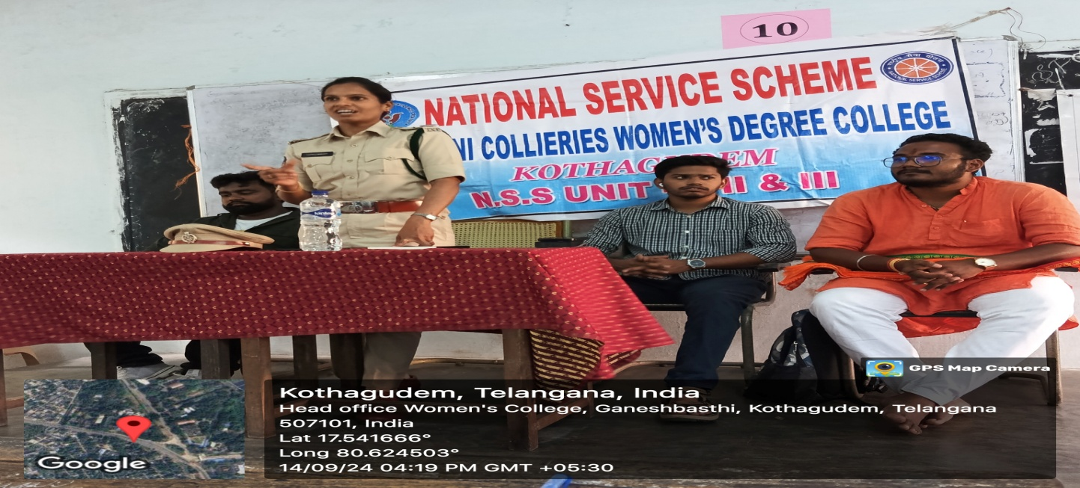
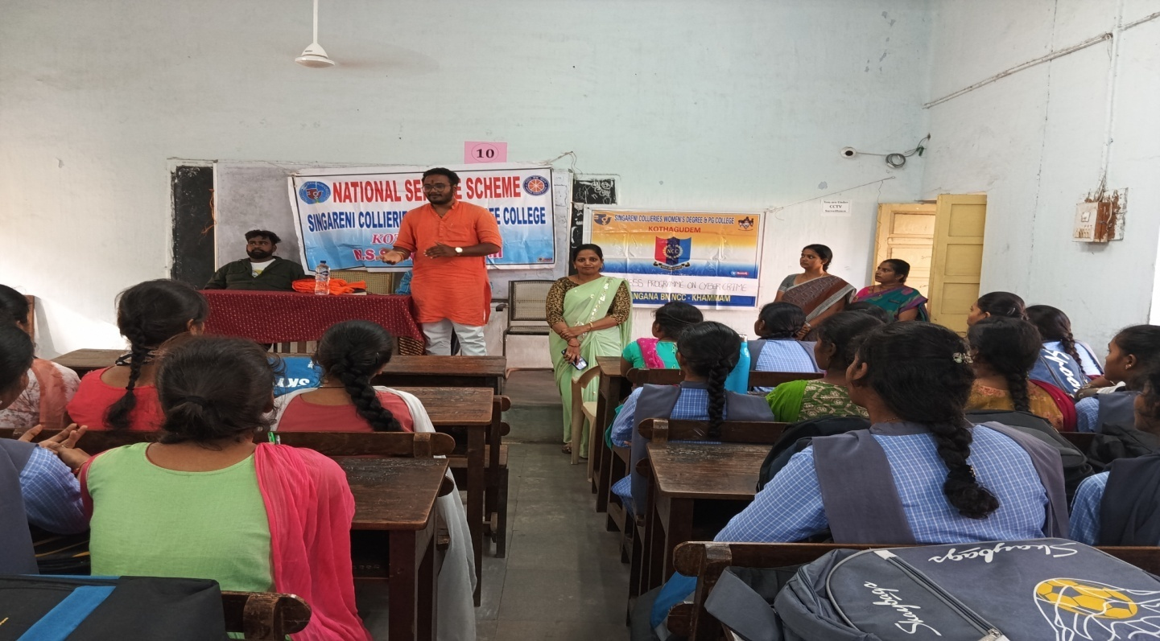

- Swachhata Hi Seva

- The Government of India’s prestigious programme “Swachhata Hi Seva” NSS PO’s, Volunteers in collaboration with Kothagudem Municipality conducted plantation program at SCWDC on 19th September 2024. Sri.T.Sheshanjan Swamy, Municipal Commissioner is the chief guest of the program.
